The Parents Club annual send-off for Academy appointees is set for 5 June. Representing the Chapter will be President Chris Havenridge, parents Club Liaison Lee Curtis, and recent graduates Conan Maltz and Ayana Cole-Fletcher.

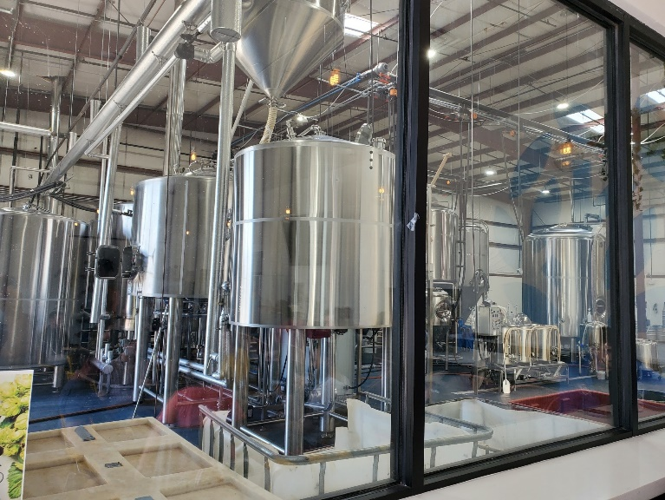

Lee Curtis reminds Chapter members and grads to come downtown Saturday **June 12** for brewery and winery good times at Chapter social (**RSVP**).  Lee and fiancé Lisa will serve as tour directors for those who wish to enjoy the streetcar experience to migrate from the brewery to the winery.  It is only $1 per person and they are fun if you haven’t tried them yet.  Please RSVP back to join the pack.  [**Lively Beerworks  -  Starts at 2 PM**](https://www.livelybeerworks.com/)[**Put a Cork In It Winery  -  Starts at 4:30 PM**](https://putacorkinitwinery.com/)

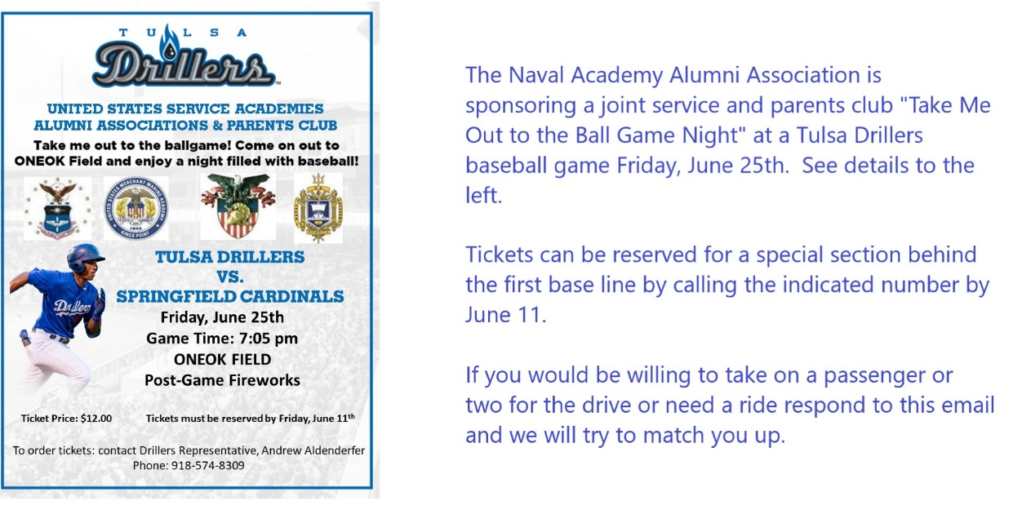

David Wilson is planning to attend and offers a ride to other chapter members who get tickets. You have to order your tickets by June 11 to sit with the group.

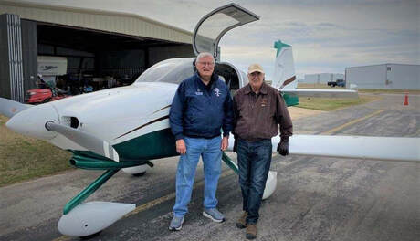

Jim Putnam and David Wilson with their RV-10 light aircraft. They are finalizing a flight orientation program for Oklahoma Academy cadets. David helped secure a T-38 training flight for Cadet JR Cook in a T-38 at Vance AFB scheduled for early June.

**Academy Football: November 5-6, Dallas, Texas, area (all times CDT)**

November 5, North Texas AOG Chapter golf tournament

November 5, Happy Hour, Troys at Texas Live, 6-8 p.m.

November 6, Tailgate for Commander's Classic

November 6, Commander's Classic football game, Air Force/Army, Globe Life Field, Arlington, Texas, time TBA ([Game tickets](https://aftickets.com/online/seatSelect.asp?createBO::WSmap=1&BOparam::WSmap::loadBestAvailable::performance_ids=3835AFD2-4611-487A-B1A0-329246932087))

**2021 Air Force Academy Football Schedule**

The Air Force Falcons have released their complete schedule for the upcoming 2021 football season. The Falcons will play eight Mountain West games, starting with Utah State at Falcon Stadium on Sep. 18.  
  
Air Force will play its typical rivals Army and Navy during its non-conference slate, but with an extra flair in scheduling for both games. The Falcons travel to Navy on September 11, commemorating the 20th anniversary of the 9/11 attacks. Air Force will be the home team against Army, but the game will be played at the new Globe Life Field in Arlington, Texas. The game has been dubbed the “Commander’s Classic” and will take place on November 6. A number of grads and chapter members have indicated they plan to attend.



